Finance and General Purposes Committee  Kidsgrove Town Council  Victoria Hall  Liverpool Road  Kidsgrove  Staffordshire  ST7 4EL  Tel: 01782 782254  www.kidsgrovetowncouncil.gov.uk | 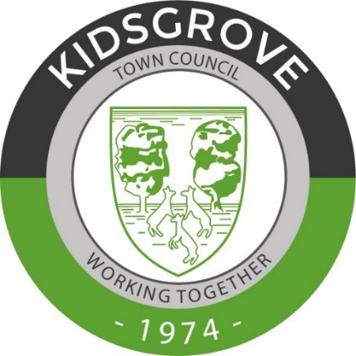

5th May 2023

To: Members of the Finance and General Purposes Committee

Dear Councillor,

You are summoned to attend a meeting of the Finance and General Purposes Committee of Kidsgrove Town Council to be held at 7:00pm on Tuesday 16th May 2023 at the Victoria Hall, Liverpool Road, Kidsgrove ST7 4EL

Yours sincerely,

H Marr

Hannah Marr

Town Clerk

Agenda

1 | To receive apologies for absence
2 | To receive declarations of Members’ interests
3 | To receive and confirm the minutes of the previous meeting  (document circulated)
4 | Public Participation
 | A period of up to 15 minutes for members of the public to ask questions or submit comments in respect of the business of the agenda
5 | To receive bank reconciliations and schedule of payments covering the period 1st February 2023 and 31st March 2023
6 | To consider matters related to the Councils year end account for the financial year 2022 – 2023
7 | To consider matters related to grant applications
8 | To consider matters related to the Councils Committee structure and associated Terms of Reference
9 | To consider, review and approve Standing Orders and Financial Regulations
10 | To consider a resolution under Section 1 of the Public Bodies (Admission to Meetings) Act 1960 to exclude the public and representatives of the press from the meeting during the discussion of the next items on the grounds that matters contain sensitive information and by reason of the confidential nature of the business being transacted
11 | To consider matters related to tenders for:-  - Christmas Lights  - Cleaning  - Telephone and broadband services

