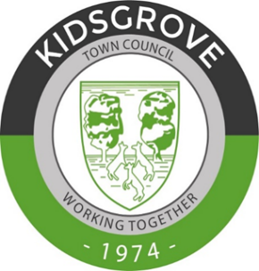
Kidsgrove Town Council
Mayor’s Charity
Christmas Market 2022
Victoria Hall, Kidsgrove
Saturday 26th November 2022

Stalls – Charity

Thank you for your interest in supporting the Christmas Market. To ensure that we can register your booking and contact you with relevant information, please complete the details below.
Name of organisation or business
Contact name
Contact address
Email Address and Contact Number
Do you have appropriate public liability insurance? Please enclose current certificate if applicable. | Yes | No
Please specific details about what your stall will provide on the day and any specific needs you may have.

Cost to Charities - £5

The organisers reserve the right to allocate stalls according to availability and their decision is final.

Please return this form by email to community@kidsgrovetowncouncil.gov.uk (preferably) or post to the address below:-

Kidsgrove Town Council
Victoria Hall
Liverpool Road
Kidsgrove
ST7 4EL

