Kidsgrove Dementia Friendly Initiative  Kidsgrove Town Council  Victoria Hall  Liverpool Road  Kidsgrove  Staffordshire  ST7 4EL  Tel: 01782 782254  www.kidsgrovetowncouncil.gov.uk | 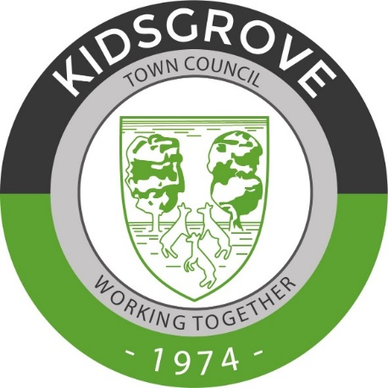
Kidsgrove Dementia Friendly Initiative
Notes from a meeting held on the 12th July 2021

Present
Cllr Dickens, M Watts (Kidsgrove Rotary), K Reader (Alsager Partnership), S Davies (Clerk to Council), E Norton (Assistant Clerk to Council),

Apologies for Absence
Cllr Cooper, Cllr S Bowyer, J Locke (Go Kidsgrove)

Agree minutes from last meeting
All agreed.

Dementia Awareness Sessions:
- The date of the first Dementia Friendly Session was agreed as 29th July at 1pm via ZOOM. After discussions following the Business agenda item, it was agreed to hold the evening session aimed at businesses on the evening of the 29th July. It was also discussed that a face-to-face session should also be arranged and that both online and face to face sessions should continue on to offer more opportunity.

- Posters were discussed and given go ahead to circulate. Sue confirmed the poster will be included in the Good News publication this month. Lizzie will post the details to the website and social media network to be shared amongst group pages. The logo of the Dementia Friendly
NOTE- Post meeting observation, GO Kidsgrove Logo to be added the posters going forward, Lizzie to contact J Locke.

- A need was identified to offer sessions aimed at children in local schools. It was agreed to add this as an agenda item for the next meeting, to get a list together of all the local schools. M Watts mentioned she has a list of contacts for some schools that we could use and would email to the Town Council Office. The Council office to draft a letter to go out to schools. Aiming to have something to approach the schools when they are back in September.

Businesses

It was agreed that the evening ZOOM session would be arranged on the 29th July at 7pm, and that it would be channelled towards businesses taking part. C Dickens will liase with J Locke to deliver the Business Posters when approaching them to gain their interest in the project.
Council office to write accompanying letter and to send on revised poster.

Advertising, Social Media and Website
The Kidsgrove Town Council now has a section for the Dementia Friendly Initiative, which the office will continue to update. Lizzie to add poster on the dementia sessions. C Dickens to send on links and other information to be added. Add to latest news on the website and temporarily change one of the tiles on the home page.
It was suggested to create as page on the website showing the working group and requesting volunteers.
Discussions were had on to whether a Dementia Friendly Kidsgrove Facebook group should be created.
K Reader emphasized a public meeting should also be held to provide information on the project and fund out what medium best suit the community, whether a Facebook Group should be set up. To also help recruit more volunteers, Sue suggested this could possibly be held in the Town Hall, and would be considered following covid announcements.

Dementia Friendly Café
Locations for consideration when the time comes. Labour Club, Town Hall and the Pavilion at Clough Hall Park. To be discussed at the next meeting as focus to remain on the Dementia Sessions and promoting the project.
Making Victoria Hall Dementia Friendly

K Reader and C Dickens to send over the Environmental Checklist that the office can use to assist in making the Town Hall Dementia Friendly.

Sensory Garden Update
- The sensory garden at the pavilion is still planned as a joint venture between the Town Council and Rotary Kidsgrove. Rotary Kidsgrove are pursuing the possibility of running a café from the pavilion for the ParkRun. It is hoped that this could be extended to a Dementia Café. Further discussion is needed to establish volunteers and progression.
It was identified the “Working Group” requires some clarification and a leader to be established to oversee all matters on the project. To be added to the next meeting’s agenda.
b) Potential for a second sensory garden within the ground of the Newchapel Recreation Ground.
Dementia Alliance Membership update
K Reader suggested following the advice on the Dementia Friends website, to continue through to Dementia Friendly status.
Review of the HW1 Action Plan
Clerk and Assistant Clerk to review the HW1 Action Plan, and amend the layout to include Go Kidsgrove/Rotary on the plan to then be discussed at the next meeting.
Other items discussed
It was agreed that other establishments in the area should be contacted to gauge interest in the project, including the Police, Churches, and the Doctors Surgeries.
Summary of Actions
- Council Office to update ‘Business’ poster and compose accompanying letter, and forward onto the group
- Cllr Dickens with J Locke to visit shops in Kidsgrove to encourage their interactivity with the Dementia Friendly Project, delivering poster and letter inviting to the training sessions
- Share the details of the project on the website and all working party to share via the social media networks.
- Council office to send invites to other Councillors to attend the sessions.
- Arrange face to face public meeting when allowed
- M Watts to email list of schools into the Office
- Office to draft letter to the schools, to be reviewed at the next meeting.
- Office to draft a letter that will invite organisations to become part of the working party
Next meeting date – Monday, 2nd August, 1:00pm – POSTPONED DATE TBA

