Neighbourhood Plan Steering Group  Kidsgrove Town Council  Victoria Hall  Liverpool Road  Kidsgrove  Staffordshire  ST7 4EL  Tel: 01782 782254  www.kidsgrovetowncouncil.gov.uk | 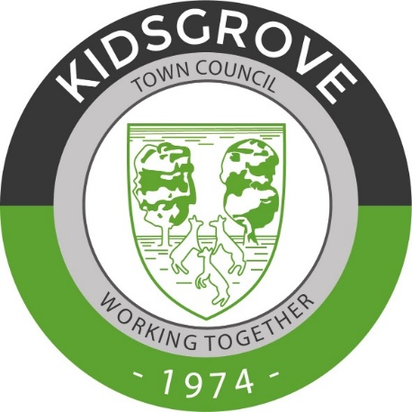
Neighbourhood Plan Steering Group notes from a meeting held via Zoom on the 3rd June 2021

Present
Cllr Stubbs, Cllr Cooper, Cllr Cartwright, Cllr Robinson, Cllr Dymond, Cllr P Waring, A Thompson (Planning Consultant), J Locke S Davies (Clerk to Council), L Norton (Assistant Clerk to Council).

Apologies for Absence
Cllr Dickens, Cllr S Bowyer

Notes from the meeting
The new commercial class E introduced in 2020 ‘commercial, business and service’ was noted.
Questionnaire
- Feedback
Ensure the individual areas are stated in the introduction to the questionnaire so the residents are aware the whole of the Kidsgrove Parish is included, and not just the Kidsgrove town itself. Keeping mindful of this with the wording of the questions too.
Bio diversity for Staffordshire Wildlife Trust – quote waiting
- Other actions
A Thompson to aim for questionnaire to be sent to Council Office by the end of the month.

Public Information Sessions
Grant Funding
‘Neighbourhood Local Planning’ may also qualify for additional funding. Grant funding provided by Locality, means groups with a neighbourhood plan are eligible to apply for up to £10,000 basic grant, with the possibility of an additional £8000. This was discussed and agreed we should be eligible for.

Any other issues
Next meeting date – TBC

