Kidsgrove Town Council  Victoria Hall  Liverpool Road  Kidsgrove  Staffordshire  ST7 4EL  Tel: 01782 782254  www.kidsgrovetowncouncil.gov.uk | 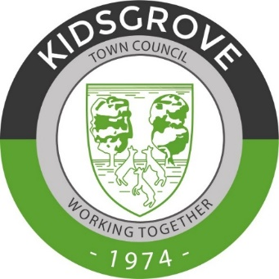
Kidsgrove Town Meeting 2019
Agenda
Kidsgrove Town Council will be holding its Annual Town Meeting on Saturday the 11th May 2019 at the Victoria Hall.
All residents are cordially invited to attend for all or part of the meeting. The afternoon will start at 3:00pm. Refreshments will be available.
Between 3:00pm and 5:00pm there will be:
- Councillor surgery – come and have a chat to your local councillors and bring along your questions and concerns.
- Information about your Town Council’s activities and plans for the coming year.
- A chance to find out about activities in your area - Community Groups are invited to ‘have a table’ to promote their work and events
Between 5:00pm and 6:00pm there will be some talks from various groups in the area – more information is to follow.
The Annual Town Meeting ‘official’ will start at 6:00pm:
Agenda:
1. To receive a welcome from the Mayor of Kidsgrove.
2. Apologies for absence.
3. To receive and approve the minutes of the meeting held in the 21st May 2018.
4. To receive the Mayor's report on the year.
5. Open forum for residents to ask any questions.
6. Meeting close.
Signed
Cllr Mike Stubbs
Mayor of Kidsgrove 3rd May 2019

